# Personal Portfolio 1

## Summary

As a Computer Science major, I enjoy working as a full stack developer and had a focus on resolving the wireframe designs of the application seen completed in figures 1.1 and 1.2 as well as working on database development as seen in the screenshot of the applications .SQL backup in figure 1.3 with the help of Malavika. As coding is a stronger discipline of mine I developed the CSS after revising the applications wireframes drawn by Nat and Shanil. With the help of Mal and Jamie, I developed the HTML backbone of the application and then developed the PHP used to connect the application to the SQL database. I also developed the PHP that echoed the database files onto the application along with login sessions and registration. In the next sprint I will be developing in JavaScript and PHP to create agency and interactivity as well as making the uploaded files hostable on the cloud.

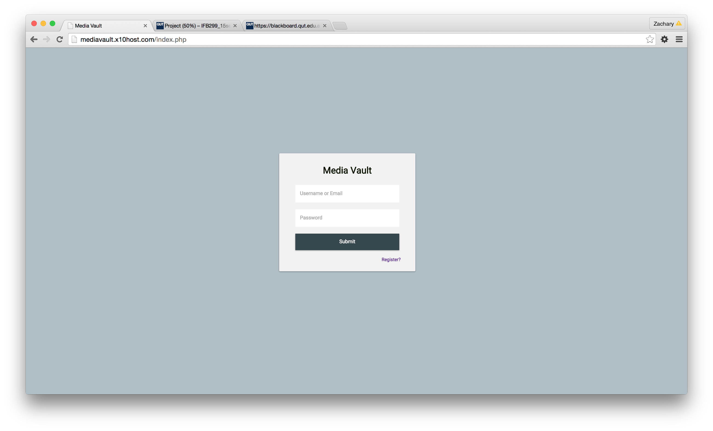

Figure 1.1

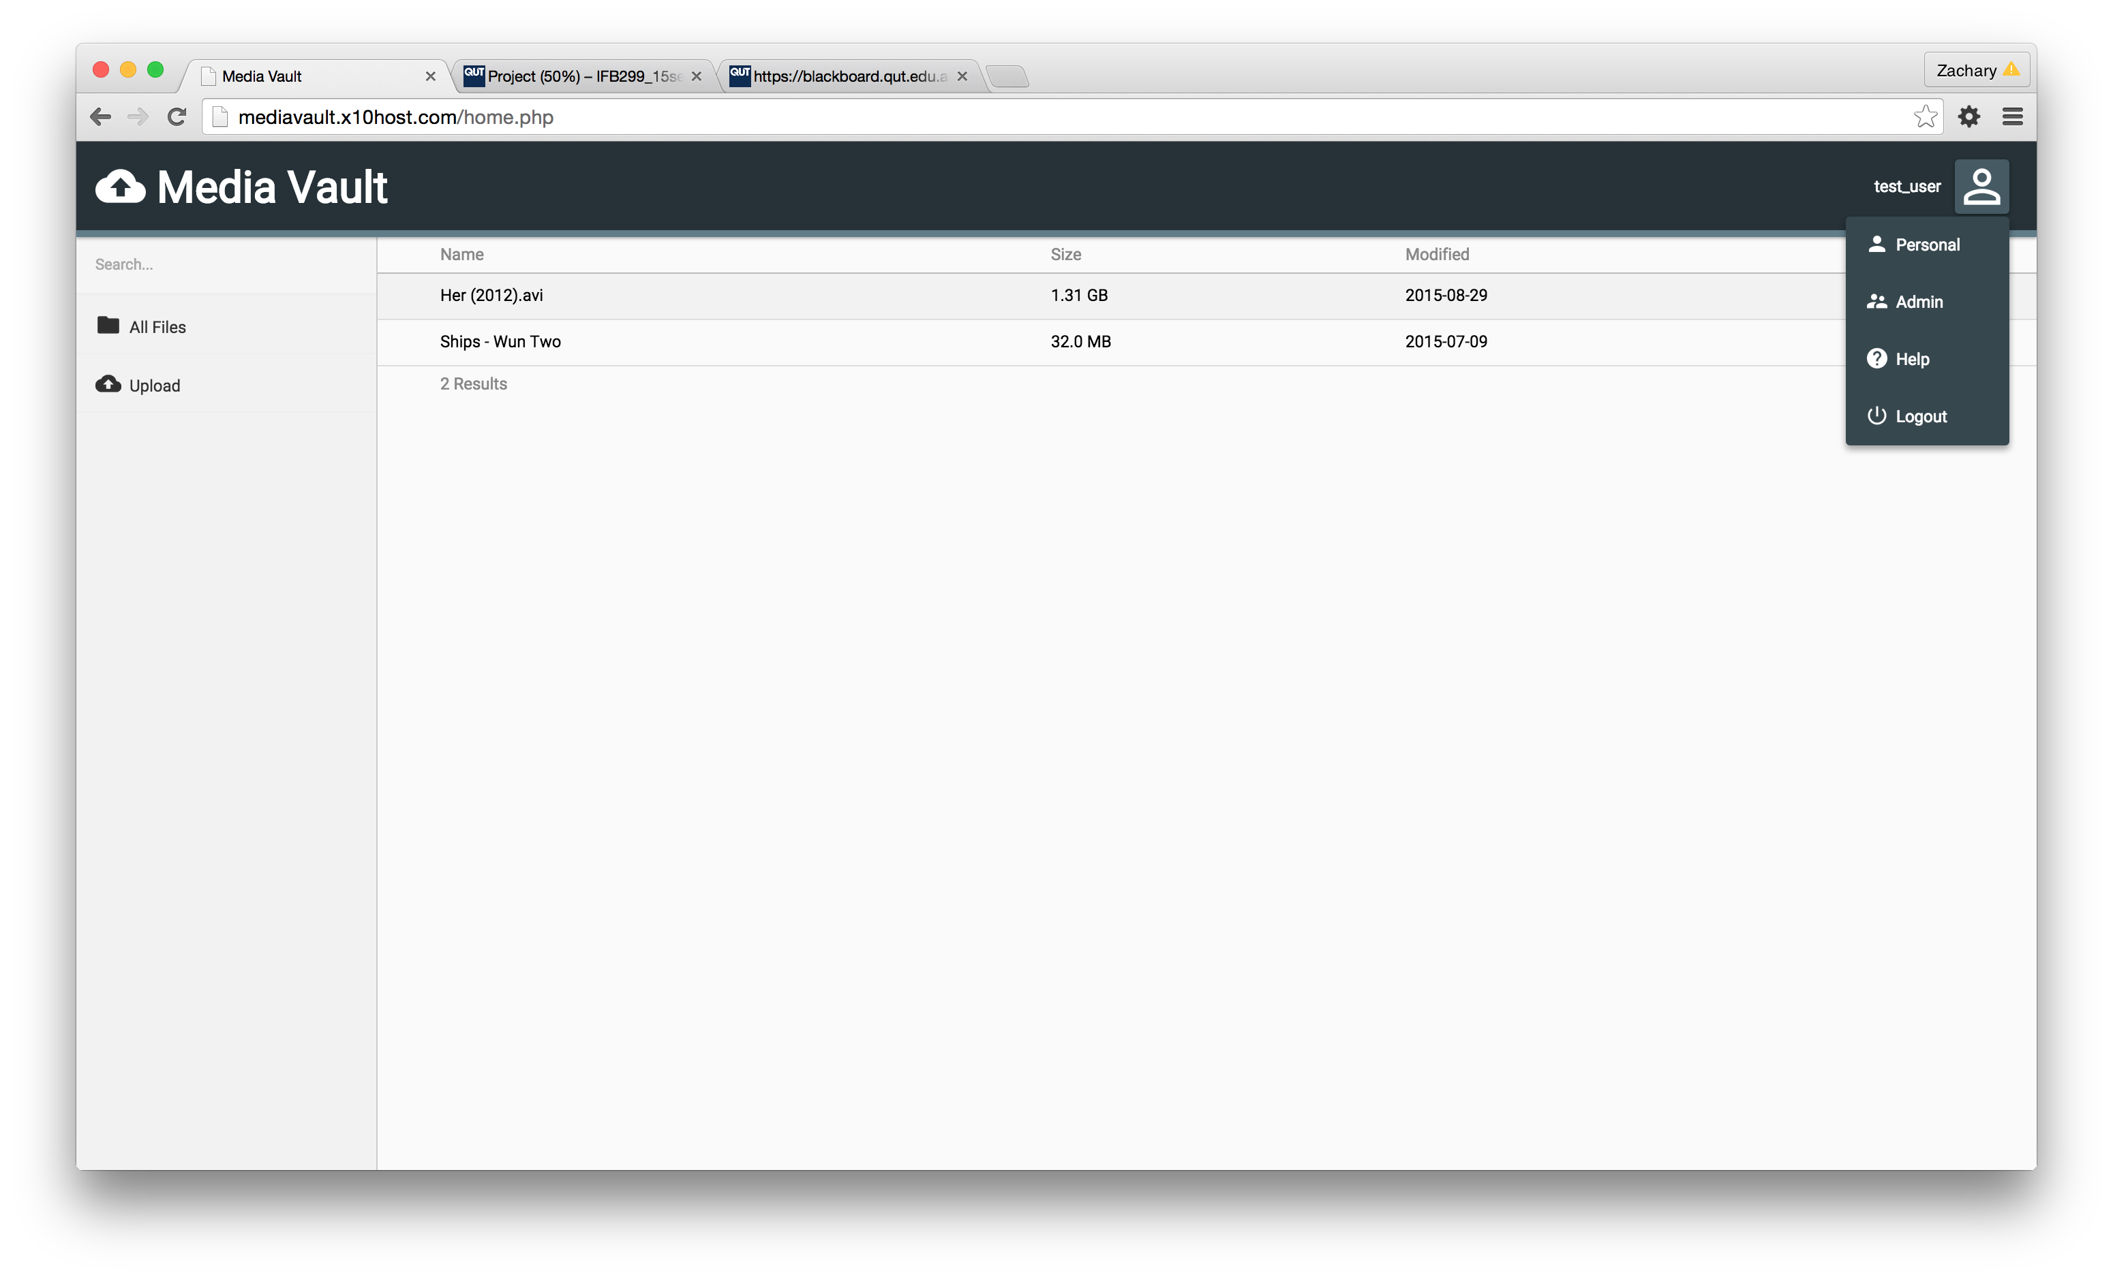

Figure 1.2

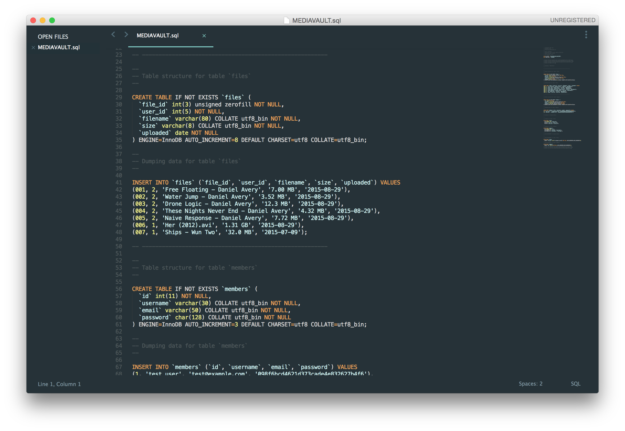

Figure 1.3

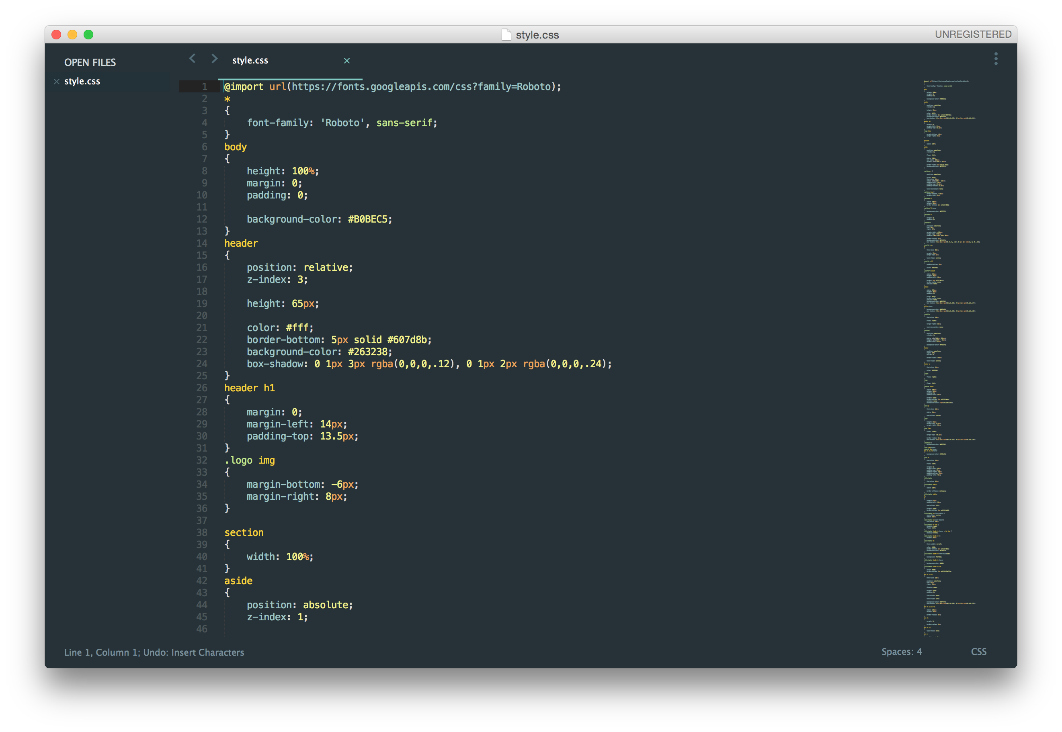

Figure 1.4

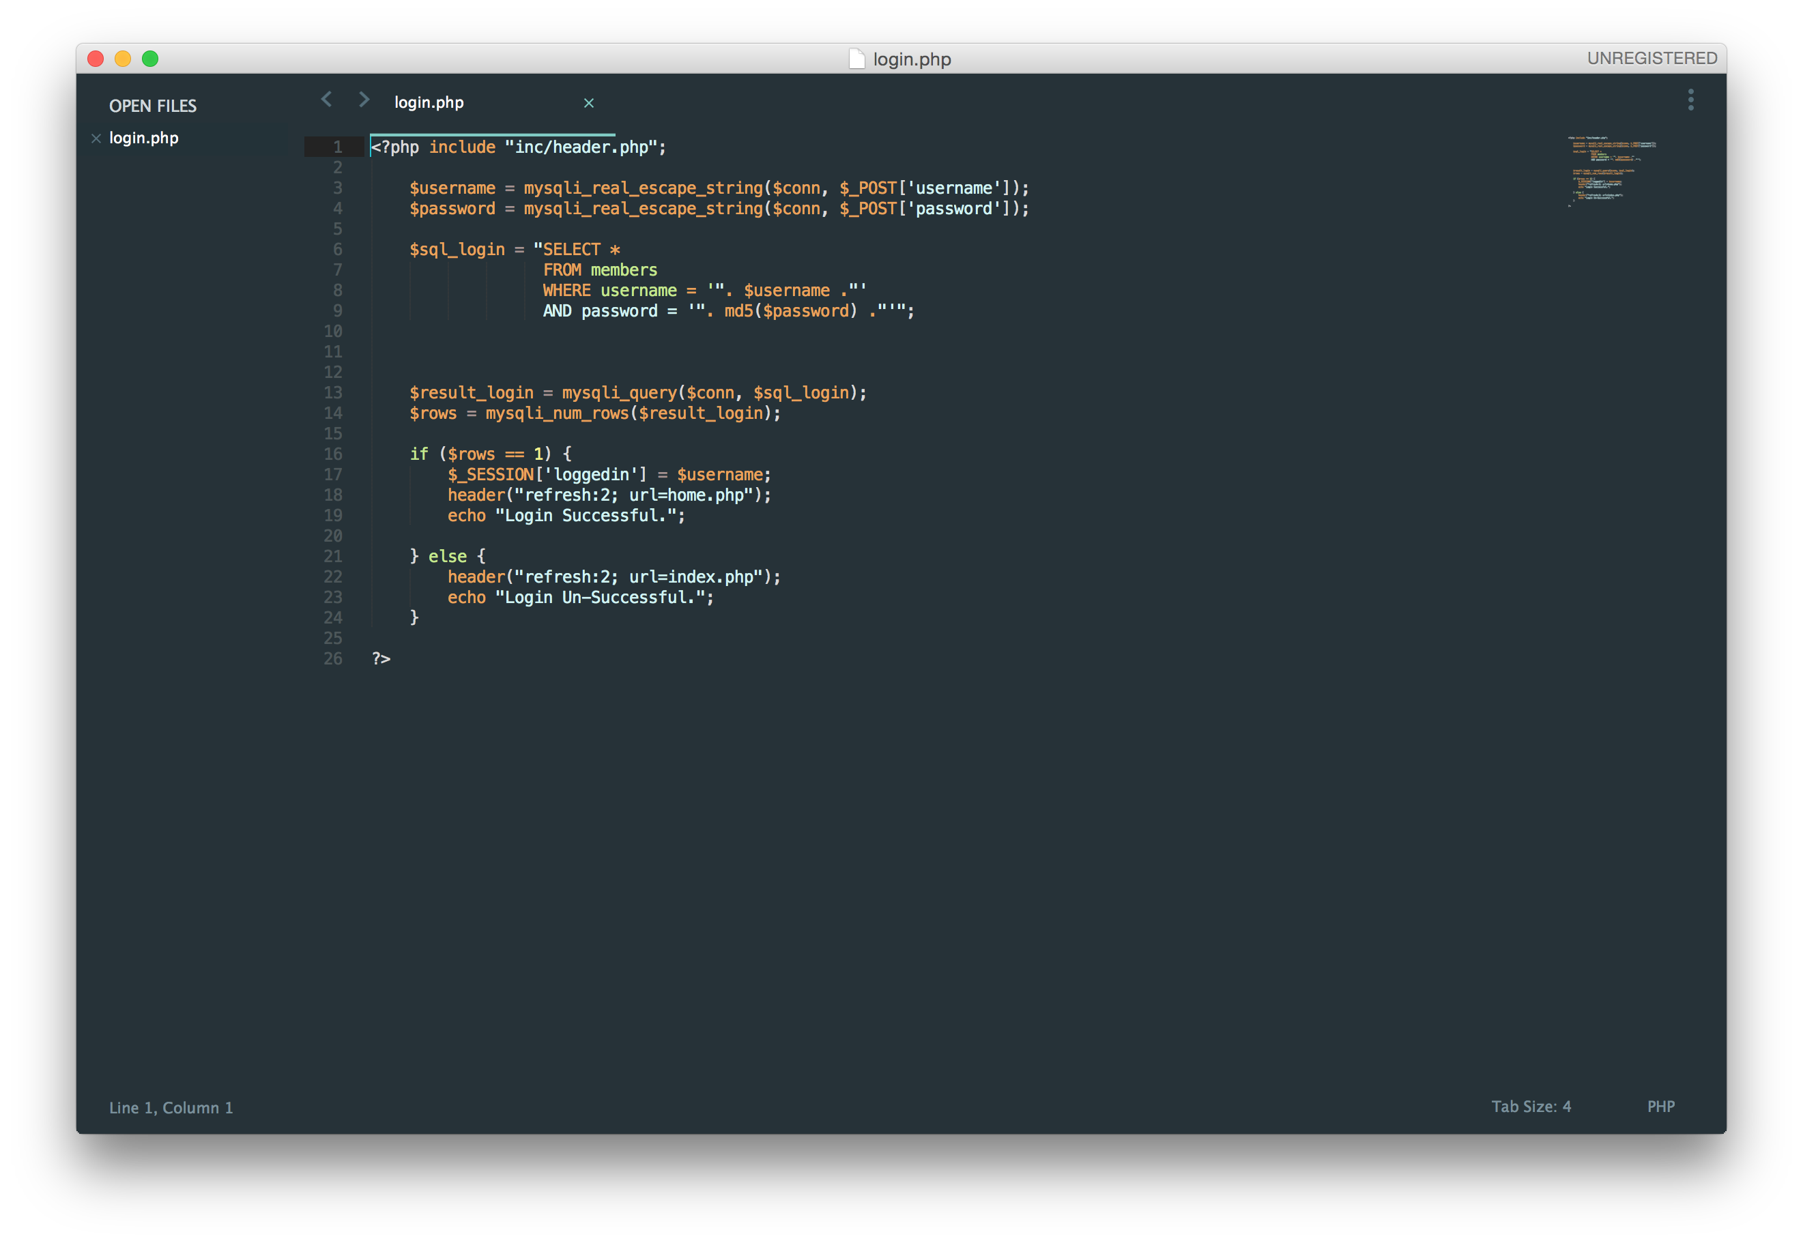

Figure 1.5